EFFECT TEAM

APRIL 11

- Level 7 shack for tomacco is not breaking
- DOORBELLS
- Add stars to Bart’s Interior

Level3 Casino sign BV wider

POST ALPHA

- Different car arrows for the cars CARY HAS THEM (fx/cars/arrow.mb)
- Fix vending machine bases moving? AHANBECK
- Make 3 different size pumpkins MMARRAFFA
- Add spotlights for Vincent in army areas r6, z3 DEVIN FIXING
- Make phonebooth wreckage more noticeable AHANBECK
- PS2 memory icon created AHANBECK
- Add sparkles to door by the damn level 3 and IN NOT WORING MICHAEL
- Burns Room Sparkles not working MICHAEL LOOKING AT THIS
- Optimize all icons AHANBECK
- LardLad in level 7 needs to be unsunk from the roof and needs collisiobns MMARRAFFA
- Re-light signs for level 7 for Sanela
- Fix Pizza sign
- Phone booths make them breakable
- Add stem to all levels for vents as per Vlad and Sheik
- Change animating signs for Sanela
- Check all doorbells for height, some
- Fix button inconsistency check with YY
- Resize the minitrack flags for Carey
- Add the triangles to make the doorbells work
- Make the sparkles for gags larger
- Re-edit all doobell pipe ini’s so that the new triangles get into the game
- Check vending for coin spew Added 25 coin callback to all vending stateprops
- Remove unused doorbells as per FOX new direction
- Add the dumpster gags in levels 2,5 3,6
- Move pelicans onto warf heads BRAD
- Fix panda box texture problem in the Moes interior, missing texture
- Change box animation BRAD
- Add the silent alarm gag in level 1 Brad
- are too high.
- Fix lemonade stand as per JP use tomacco stand
- Fix the Larry the Looter gag, add window, gum etc….
- Make sure the fmv’s play full
- Change my shader name on the shadow of the vending machine and re-export them to all levels (Sarah can change back)

INTERACTIVE GAG PROGRESS SHEEt
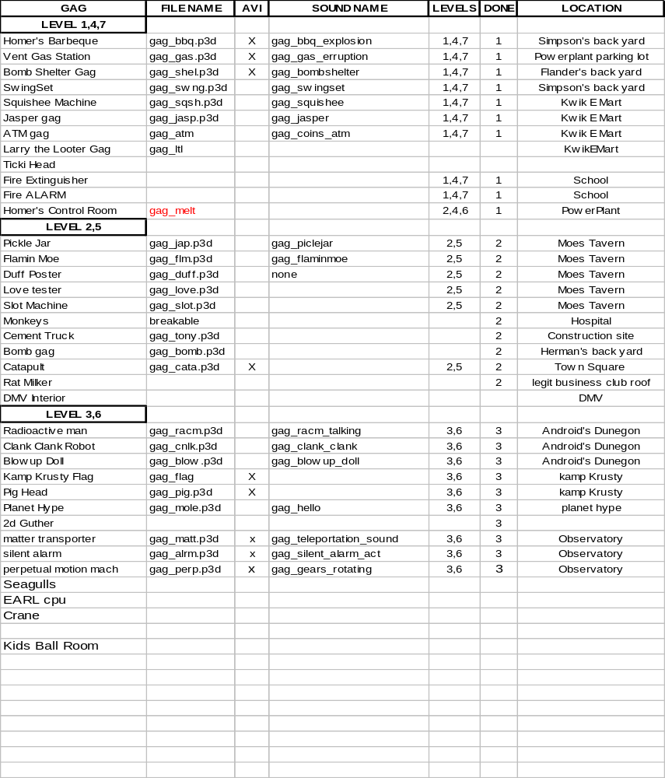

INTERACTIVE GAG CONTENT LIST
NEWGAGS:
Meteor lands in the Flanders backyard and player may interact with the small rock (L1Z1)
- Aztec head in the suburbs - fire from mouth (L1R1)
- Sun blocker in Burns backyard (L4R4b)
- House where a lady throws cats at your from the doorway (L1R7)
- Melted Guns Playground (L1R1)
- Barrel of monkeys in lab press button and monkey exit one window and go up another (see no evil? Or barrel of monkeys reference) (L2Z1)
- Merry go round spins on trigger (L1R1)
- Swings - same as in Simpson’s back yard (L1R1)

SUBURBS:
- Doorbell on 17 locations that will play specific dialog. <HOLD OFF>
  - Bomb Shelter: Pressing action causes door to slightly open and Rod and Todd do0r of shelter opens
- Homer’s terminal: Pressing action causes a green point light to flash, and loud explosion sound (plus screaming). Talk to Cary RE: camera shake
- Swing set behind Simpson’s House. Pressing action causes swings to fall apart, sound would be nice.
- BBQ (remove lid), pressing action causes jet of flame to fire upwards.
- ‘Vent Gas button’ linked to radioactive gas storage tank as in 3F05. Vent gas tank would have to be built.

Kwik -E-Mart Interactive Gags (level 1, 4 and 7) (Eric Madill)
- Arcade Machines: using action causes arcade machine to make noises, and display different. Preferably, we could use a camera change showing Larry the Looter sequence or Escape from Death Row. Don’t do drugs message after game finishes. (camera move)
- Squishy Machine: Using the action button on the Squishy machine causes a stream of red liquid to spray out.
- (Halloween Level only) Squishy Machine: Chief Wiggum’s legs sticking out of Squishy machine. Pressing action causes legs to move as if the corpse is being stirred.
- Frozen Jasper in freezer: pressing action causes him to moan and stir.(camera can we see it) get picture from CM.
- ‘Silent Alarm’ switch which causes line of dialog “Silent Alarm Activated!” to boom out. Should be flashing red light

Simpson’s House Interactive Gags (level 1, 4 and 7) (Eric Madill)
- TV: Using the action button on the TV causes light from TV to brighten Homer/room

Downtown Interactive Gags (level 2 and 5)
- Hitting Popsicle skyscraper causes a shower of Popsicle particles to appear.
- Catapult, fires as in 4F15, in the part in front of city hall
- Whacking day memorabilia ??? Banners downtown

Moe’s Tavern Interactive Gags (level 2 and 5) Eric Madill
- Pickle Jar: Pressing action causes eggs in pickle jar to move around
- Love Tester: Pressing action causes love tester lights to flash and machine to shake.
- Slot machine: Pressing action causes machine to light up and shake (same as Burns Casino) tie in a sound “you a loser haha (repeat))
- Rotating poster- 7 duffs, out of state liquor license, Bartenders do it till you barf
- Flaming Moe’s

Seaside Interactive Gags (level 3 and 6)
- Flag at Kamp Krusty: pressing action causes flag to go down and be replaced with Bart flag.
- Pig head on a stick at Kamp Krusty: pressing action causes character to touch it and say, “Ew”
- Moleman should be in the Cadillac crashed into planet hype
- 2d images of Gunter, Ernst and white tiger

Observatory Interactive Gags (level 3 and 6) Eric Madill
- Telescope: Pressing action causes player to be given a view of one of several 2d images i.e. moon, UFO, pig flying through air.
- Perpetual Motion Machine: Pressing action on the Frink Motion Machine causes it to start animating and never stop.
- Trying to use restricted door off to side causes alarms to sound and red lights to flash. Plays line of dialog “Silent Alarm Activated!”
- Frink matter transmitter: Pressing action causes a green flash and monkey in one booth to be transported to a second booth and back to first booth (occasionally put Moleman or Ralph in transmitter, line of dialog “I’m all dead inside”).

Androids Dungeon Interactive Gags (level 3 and 6) Eric Madill
- Radioactive man Cut out: Pressing action causes arm to move and voice to say, “Up and atom!”
- Blow up doll of sci-fi woman: Pressing action inflates doll with breasts and finally butt inflating last, the doll then deflates.
- Robot from Clank Clank! You’re dead!: pressing action causes door to swing open revealing dead midget inside.

Simpsons 2 New Interactive Objects

These new props are largely intended for use in the downtown and seaside levels. There is currently a lack of interactivity in Downtown and Seaside.

Evergreen Terrace (Levels 1, 4 and 7)

- Melted down guns playground equipment: Sliding down slide or pressing action causes guns to fire. See episode DABF19 for reference

Downtown (Levels 2 and 5)

- Monkey on top of Lard Lads that throws coins at you: Monkey throws coins when you get too close
- Extending ladder on fire truck: User presses action to extend ladder, the user can then use the ladder jump or slide down the side of the ladder collecting coins
- Extending fire escape ladder: Pressing action lowers fire escape for use in jumping puzzles
- A-bomb in the back of Herman’s: Pressing action causes bright green flash with get hit animation and pain sound
- Fat Tony Cement Truck: Pressing action causes cement and stiff body-shapes covered in cement to come out
- X-Ray machine being delivered to the back of hospital: Pressing action shows the characters skeleton to be displayed on front of the machine
- Crates of monkeys behind Dr. Nick’s lab: Smashing crate with stomp attack causes monkeys to escape
- Rat-Milker on roof of LBSC: Pressing action causes rats to escape and milk to fly out
- Evidence locker outside police station: Pressing action causes locker to open and coins to come out
- DMV-Interior: Camera setup in side area to take pictures of Moleman: Pressing action causes bright white flash which hurts Moleman, he then says a line of dialog i.e. Owwww ATTN Priority on this gag
- Empty fire extinguisher: To be used on public buildings, pressing action causes a small pop and a single coin to come out
- Smashable ATM machine: breaking ATM causes coins to come out

Seaside (Levels 3 and 6)

- Seagull: Pressing action causes seagull to cough sickly, then spit out a coin
- Breakable E.A.R.L. computer inside lighthouse: Smashing computer causes coins to come out. See 3F24 for reference
- Kid’s ball-room outside Wall-E-Weasels: Pressing action a stream of balls and children to come out
- Crane attached to a large crate with ‘Hot Pants’ written on the side: Pressing action on crane’s controls smashes crate against side of building, causing the crate to explode in a shower of hot-pants and coins
- Empty fire extinguisher: To be used on public buildings, pressing action causes a small pop and a single coin to come out
- Smashable ATM machine: breaking ATM causes coins to come out

Special Case Item

- Human Cola Vending Machine: the designers will place these throughout the world with the world builder. These machines can only be destroyed with a ‘Stomp’ attack and will release a large amount of coins into the world. For example, a box will be placed next to a vending machine, the user will jump onto the box and then double-jump-stomp the vending machine.

